1. Tulsi
There are four types of tulsi mentioned in ayurvedic texts ie Rama, Krishna, Vana & Kapoor Tulsi.
For over the centuries Tulsi (the queen of herbs) has been known for its remarkable healing properties.
- Tulsi is taken as herbal tea.
- The oil extracted from the Karpoora Tulsi is mostly used in the herbal toiletry. Its oil is also used against insects and bacteria.
- The Rama Tulsi is an effective remedy for Severe acute Respiratory Syndrome. Juice of its leaves gives relief in cold, fever, bronchitis and cough.
- Tulsi oil is also used as an ear drop.
- Tulsi helps in curing malaria.
- It is very effective against indigestion, headache, hysteria, insomnia, and cholera.
- The fresh leaves of Tulsi are taken by millions of people every day.
- Many people wear Tulsi beads, which is said to have certain physical and medicinal properties.
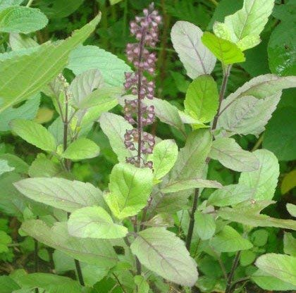

2. Aloe Vera
The aloe vera grows only under the sun with well-drained dry or moist soil. Although the plant tastes like a turd, it’s still edible. The sap from aloe vera is extremely useful to speed up the healing & reducing the risk of infections for :
- wounds
- cuts
- burns
- reducing inflammation
Apart from its external use on the skin, aloe vera is also taken internally in the treatment of :
- ulcerative colitis (drinking aloe vera juice)
- chronic constipation
- poor appetite
- digestive problems
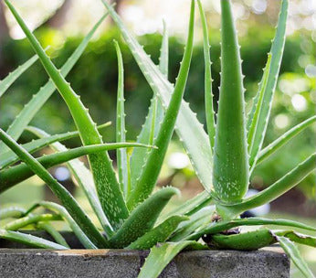

3. Gotu Kola
The gotu kola acts on various phases of connective tissue development and stimulates healing of :
- ulcers
- skin injuries
- decreasing capillary fragility
- stimulation of the lipids and protein necessary for healthy skin
- Leaves are thought to maintain youthfulness.
- Crushed leaves are poulticed to treat open sores.
The gotu kola can also be used to :
- treat leprosy
- revitalize the brain and nervous system
- increase attention span and concentration
- treat venous insufficiency
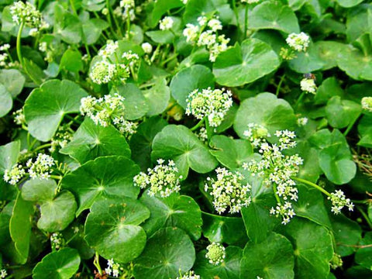

4. Calendula
It grows in almost any type of soil condition. It has no problem with nutritionally poor, very acidic or very alkaline soils, just as long as it’s moist. Well known as a remedy for skin problems, the deep-orange flowered pot marigold variety is applied externally to :
- bites
- stings
- sprains
- wounds
- sore eyes
- varicose veins
- Internally it is used to treat fevers and chronic infections.
- The tea of the petals tones up circulation and, taken regularly, eases varicose veins.
- Applying the crushed stems of the pot marigold to corns and warts will soon have them easily removable.
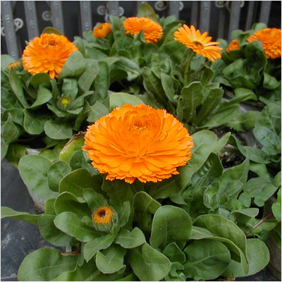

5. Basil
You must have used basil lot many times in food but have you ever tried it to heal flatulence? It has the power to treat:
- Cuts
- Lack of appetite
- Stomach gas
- scrapes
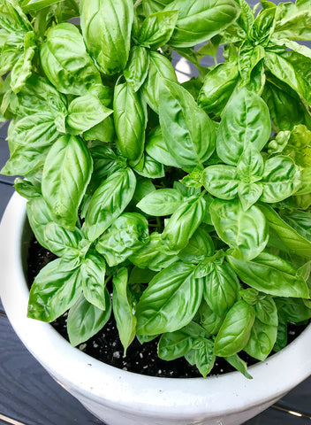

6. Thyme
It is mostly known for its strong antiseptic nature. It is wonderful when it comes to the treatment of:
- Congestion
- Stomach gas
- Coughs
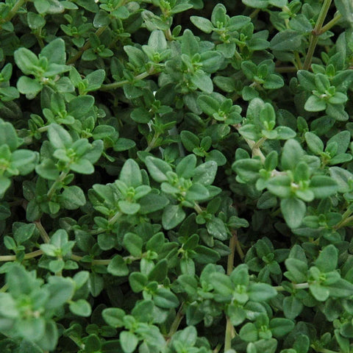

7. Rosemary
Rosemary is the great reviver. This perennial woody herb stimulates energy and optimism and sharpens memory and concentration by bringing more oxygen to your brain, according to UMMC. It’s a wonderfully stimulating alternative to caffeine when you need that second wind!
A row of these long-lived and drought-tolerant plants makes a beautiful, bee-friendly, evergreen hedge. You may only need one plant in your garden, as a little bit goes a long way.

8. Lavender
Long recognized for its sweet perfume, lavender also boasts medical benefits as a nervine and mild antidepressant. UMMC suggests adding it to your bath to alleviate stress, tension, and insomnia. It's also used in creams to treat sunburns and acne.
Woody lavender plants prefer hot, sunny, and dry environments. The fresh flowers are tasty in small doses when added to salads, honey, butter, lemonade, and even shortbread cookies. If you’re crafty, try sewing up an herbal heating pad or eye pillow with the fragrant dried flowers.
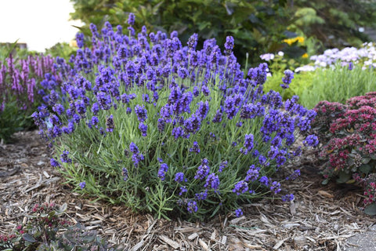

9. German Chamomile
Delicate, apple-scented chamomile demonstrates that mildness does not mean ineffectiveness. Primarily grown for its small, yellow-bellied flowers, NCCAM reports that chamomile is one of the best children’s herbs for treating colic, nervous stress, infections, and stomach disorders.
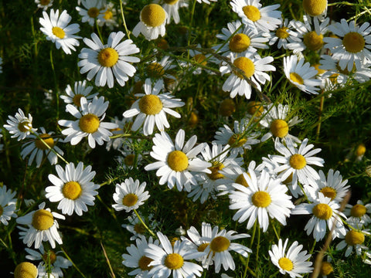

10. Fenugreek, Methi
Fenugreek seeds are nourishing and taken to :
- encourage weight gain (take note, anorexics)
- inhibit cancer of the liver
- lower blood cholesterol levels
- treat inflammation and ulcers of the stomach and intestines
- drain off sweat ducts
- for body building
- for late onset diabetes
- poor digestion
- insufficient lactation
- painful menstruation
- labor pains
- freshen bad breath
- restore a dull sense of taste
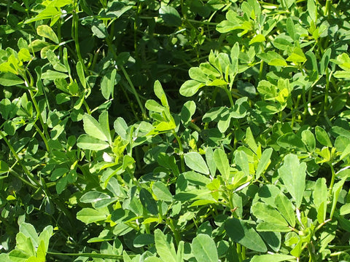

11. Sage
Salvia, the Latin name for sage, means ‘to heal’. Internally, the sage is used for :
- indigestion
- flatulence
- liver complaints
- excessive lactation
- excessive perspiration
- excessive salivation
- anxiety
- depression
- female sterility
- menopausal problems
On the other hand, it is used externally for :
- insect bites
- skin infections
- throat infections
- mouth infections
- gum infections
- skin infections
- vaginal discharge
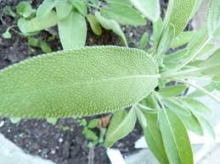

12. Peppermint
Peppermint is sometimes regarded as ‘the world’s oldest medicine’, with archaeological evidence placing its use at least as far back as ten thousand years ago. Pepeprmint are naturally high in manganese, vitamin A and vitamin C. Crushed leaves rubbed on the skin help soothe and relax the muscles. Infused peppermint leaves are used to :
- reduce irritable bower syndrome
- against upset stomachs
- inhibit bacterial growth
- treat fevers
- flatulence
- spastic colon
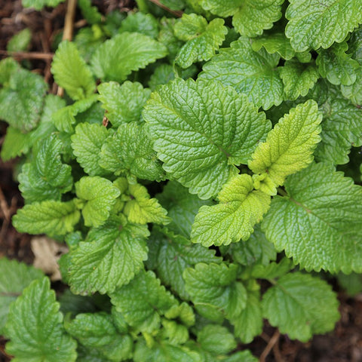

13. Lemon Balm
The reason the plant is called lemon balm is because of the lemon minty scent of the leaves. The flowers, which appear during the summer, are full of nectar. The crushed leaves, when rubbed on the skin, are used as :
- mosquito repellent
- herpes
- sores
- gout
- insect bites
Infusion of the leaves with water are known to treat :
- colds
- fevers
- indigestion due to nervous tension
- digestive upsets in children
- hyperthyroidism
- depression
- mild insomnia
- headaches
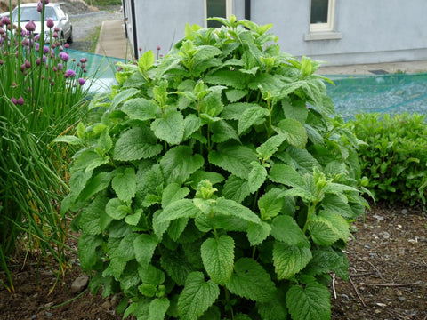

14. Globe Artichoke
A bitter tasting plant that requires a lot of sun, the cardoon has become important as a medicinal herb in recent years following the discovery of cynarin. The cardoon leaves, best harvested before flowering, helps to :
- improve liver and gall bladder function
- stimulate the secretion of digestive juices
- lower blood cholesterol levels
- treat chronic liver and gall bladder diseases
- jaundice
- hepatitis
- asteriosclerosis
- early stages of late-onset diabetes
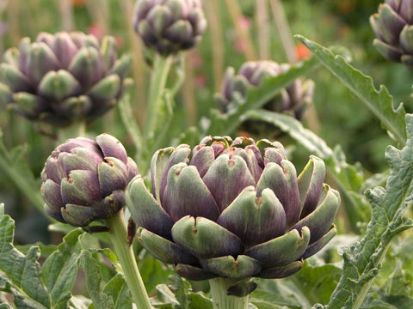

15. Ashwangandha
Ashwagandha is best known for stress Reduction, Neural Protection, and a Lot More from an Ancient Herb
The benefits of ashwagandha are many; in addition to promoting fertility, aiding in wound care, and boosting the immune system, some other benefits are:
- Diuretic, Sleep aid
- Galactogogue
- Anti-epileptic
- Anti-tumor, Pain relief
- Eye health
- Heart tonic
- Lowers cholesterol & Regulates blood sugar
- Reduces depression and anxiety, Combats stress
- Fights cognitive decline due to brain cell degeneration
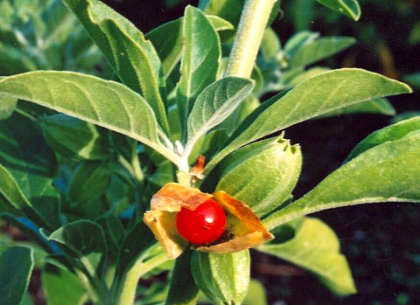

16. Lemon Grass
Lemongrass has been reported to have innumerable therapeutic and other health benefits.
- alleviate certain respiratory conditions including laryngitis and sore throats
- anti-pyretic property which reduces high fevers.
- useful for all types of pain including abdominal pain, headaches, joint pains, muscle pains, digestive tract spasms, muscle cramps, stomachache and others
- lemongrass inhibits bacteria and yeast growth.
- beneficial for nervous and stress-related conditions.
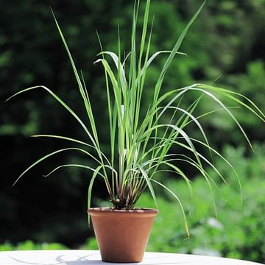

17. Bryophyllum, Panfuti
Bryophyllum calycinum, Bryophyllum pinnatum, also known as the Air Plant, Life Plant, Miracle Leaf, Goethe Plant and the Katakataka (Filipino)) is a succulent plant native to Madagascar.
- The leaf or its juice is taken for diabetes.
- Leaf paste application stops bleeding and heals wounds.
- The burnt leaf (mashi) made in to paste with coconut oil cures burn.
- To prevent septic to cuts from sharp instruments, 15 leaves with four pepper corns roasted, powdered and mixed in cow ghee is applied.
- Leaf paste boiled in oil cures sciatica and rhematic pains.
- One leaf eaten raw with one pepper corn first thing every morning for 3 to 7 days cures urinary stones.
- The leaves can be used raw for making chutneys or tamblis.
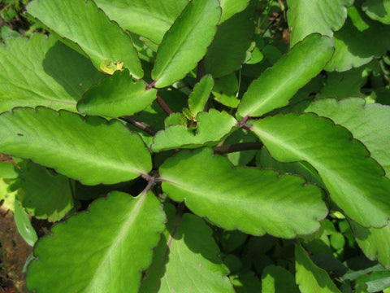

18. Rui
RUVA, Purple ( Ekke, Rui,arka ) Calotropis gigantea
- The leaves and flowers of both the varieties are used for pooja of Shiva, Hanuman and Devi.
- Leaves of both varieties are used for fomentation to paining joints.
- Fomentation of leaves after application of castor oil relieves stomach pain of infants.


19. Costus
Costus igneus, commonly known as insulin plant in India, belongs to the family Costaceae. Consumption of the leaves are believed to lower blood glucose levels, and diabetics who consumed the leaves of this plant did report a fall in their blood glucose levels.
The fresh leaves of this plant is chewed two times daily for 1 week after 1 week, 1 leaf should be chewed twice a day this dosage should be continued for 1 month. It is said that this treatment is effective in bringing blood sugar levels under control in diabetes patients.
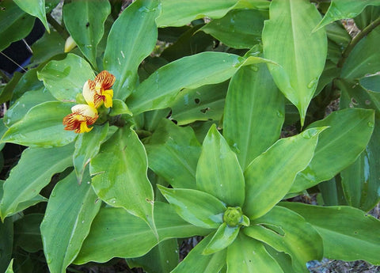

20. Khus
It has anti-inflammatory and antiseptic effects that provide relief from inflammations in circulatory system and nervous system. Khus khus is used to create a tonic bath, which is the reason why it is often included in high quality soaps.
It is a boon for individuals suffering from rheumatism, arthritis, gout, muscular aches, dryness and cracking of skin etc.
The oil obtained from khus khus has sedative effect and aids in the treatment of emotional outbursts, such as anger, anxiety, epileptic and hysteric attacks, restlessness, nervousness, etc.
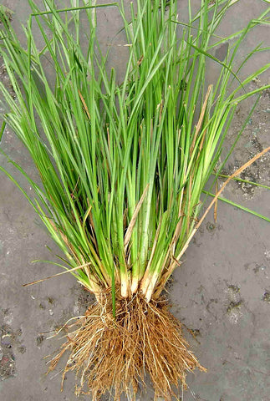

21. Vitex Negundo
Commonly known as the five-leaved chaste tree, is a large aromatic shrub with quadrangular, densely whitish, tomentose branchlets.
Key therapeutic benefits:
- Because of its anti-inflammatory, antibacterial and antifungal properties, the plant is useful in treating sores and skin infections.
- Five-Leaved Chaste Tree relieves muscle aches and joint pains.
- The herb is effective in treating vaginal discharge.
